A THIRD GENERATION OF Superior sound
Sennheiser Introduces new MOMENTUM Wireless

Wedemark/Berlin, September 5, 2019 – Sennheiser’s premium MOMENTUM headphone range enters its third generation, with the launch of the new MOMENTUM Wireless at IFA 2019 (September 6-11). The headphones are the latest addition to the audio specialist’s iconic range that offers superior sound, a modern design aesthetic, cutting-edge technology, and a touch of handcrafted indulgence to every moment. Thanks to Auto On/Off and Smart Pause features, the new MOMENTUM Wireless headphones start up instantly when unfolded, and sense when put on or taken off to pause and resume playback, ensuring a world of uncompromised sound is just a heartbeat away. Designed to be supremely comfortable for all-day listening sessions, they feature genuine sheep leather and soft padding on the earpads and headband. Active Noise Cancellation and a Transparent Hearing function allow listeners to experience their audio on their terms, by either blocking out the world or staying aware of their environment. One-touch voice assistant access lets them stay connected on the move.

“Our MOMENTUM range has been synonymous with a unique blend of superior sound quality, progressive technology and remarkable craftsmanship, and with the third generation, we are bringing this contemporary classic into the always-on, connected age,” said Stephane Hareau, Global Head of Products Consumer at Sennheiser. “The new MOMENTUM Wireless is a smart headphone that gives you fast, effortless control: whether enjoying entertainment or making calls, escaping it all or staying connected – it anticipates your needs and lets you interact intuitively and instantly,” added Sebastian Rodens, Product Manager at Sennheiser.

Never Lose your Rhythm Again
With the new generation of MOMENTUM Wireless, interaction is supremely intuitive thanks to a unique combination of features that offer fast access to one’s music. Auto On/Off instantly turns on or off playback as the earcups are folded open or closed, while Smart Pause uses proximity sensors to pause audio when the headphones are removed and to resume playback when they are slipped back on. Just as effortless is a three-button interface that gives control of audio or calls – all without the need to consult a manual. Via a dedicated button, the MOMENTUM headphones feature one-touch access to voice assistants such as Siri and Google Assistant, while Amazon Alexa integration will be available soon with a firmware update via the Sennheiser Smart Control app. Pairing is effortless as well, thanks to NFC and an automatic pairing mode that makes setting up on initial activation a breeze.
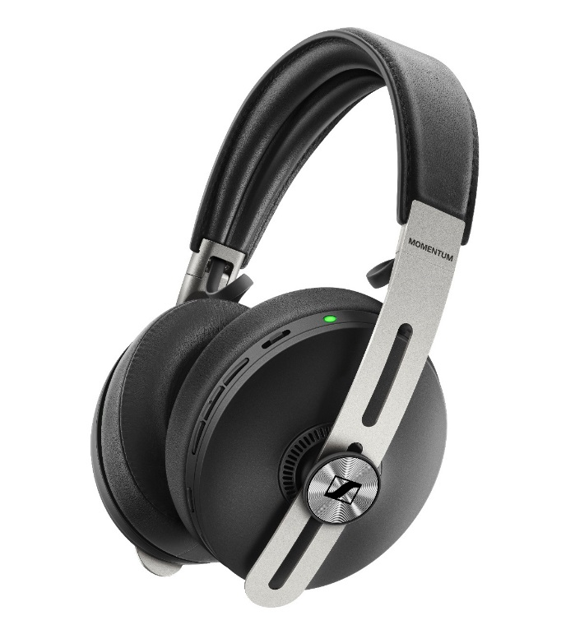

The new MOMENTUM Wireless headphones are the latest addition to Sennheiser’s iconic range that offers superior sound, a modern design aesthetic, cutting-edge technology, and a touch of handcrafted indulgence to every moment.

Hear the Difference
Sennheiser’s new MOMENTUM Wireless headphones offer outstanding sonic performance. The high-quality speaker system is powered by 42mm transducers to reproduce the balanced depth and precision of a studio recording. This flawless audio performance is ensured by Bluetooth 5 compatibility and support for codecs including aptXTM, AAC, and SBC, as well as aptXTM Low Latency for perfectly synchronising audio with onscreen visuals. Whether listeners are enjoying music, movies or podcasts or simply want to fine-tune the audio experience to their taste, it is possible to tailor the audio experience with the built-in equalizer via Sennheiser’s Smart Control app.

Perfectly in Tune, Wherever, Whenever
No matter where the MOMENTUM Wireless headphones are being enjoyed, they are able to adapt to every environment. When on the go, Active Noise Cancellation with three different modes blocks out the outside world. Alternatively, the Transparent Hearing function lets listeners enjoy their music and still be aware of ambient sounds in their surroundings – perfect for environments that require greater situational awareness.

Featuring three ANC modes and a Transparent Hearing function, the new MOMENTUM Wireless headphones are able to adapt to every environment.

A Sophisticated Harmony of Form and Function
Like all MOMENTUM headphones, the new generation model offers a sophisticated harmony of form and function. While the genuine sheepskin leather of the earpads and pearl-blasted stainless steel sliders express a subtle luxury, they also functionally enhance every interaction. The leather on the padded ear pads and headband is ultra soft for improved wearing comfort, even for longer listening sessions made possible by the 17-hour battery life. Meanwhile, the strong yet lightweight stainless steel sliders and hinges maintain a purity of design while also ensuring the headphones remain robust enough for a lifetime of listening on the move. The folding headband design allows the headphones to fold away in their fashionable fabric carry case.

Hard to Put Down, Difficult to Lose with Tile
With the new MOMENTUM Wireless, it is easy to lose oneself in the music, but thanks to smart Tile technology, the headphones are almost impossible to misplace. The integrated Bluetooth tracker ensures users can find their headphones via the Tile app.

The new MOMENTUM Wireless is available in black as of now for 399 EUR (MSRP). A sandy white color variant will be available from November.

About Sennheiser
Shaping the future of audio and creating unique sound experiences for customers – this aim unites Sennheiser employees and partners worldwide. Founded in 1945, Sennheiser is one of the world’s leading manufacturers of headphones, loudspeakers, microphones and wireless transmission systems. Since 2013, Sennheiser has been managed by Daniel Sennheiser and Dr. Andreas Sennheiser, the third generation of the family to run the company. In 2018, the Sennheiser Group generated turnover totaling €710.7 million. www.sennheiser.com

Global Press Contact
Sennheiser electronic GmbH & Co. KG
Jacqueline Gusmag
Communications Manager Consumer
T +49 (0)5130 600-1540
jacqueline.gusmag@sennheiser.com

